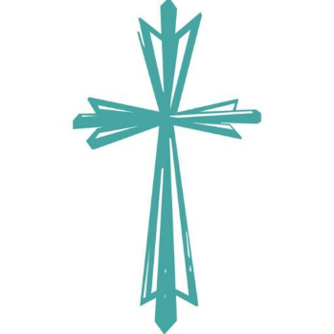
St. Luke WORSHIP SERVICE RESPONSE SHEETS revised for Fall 2023
St. Luke Lutheran Church
(St. Luke CONFIRMATION STUDENTS are required to complete & return a minimum of 2 per month – thanks for your input!!)

Name:____________________________Date:______________
- Something new, different, or special I noticed about God, church, or scripture today.

- ONE Bible sentence or verse which was emphasized today. (Write out the WHOLE sentence or verse)

- Three complete sentences giving a summary of today’s sermon.

A.

B.

C.

- A question I have about today’s worship or today’s theme.

- A creative response to today’s worship service: Please use the back to create ONE of the following (must be related to today’s worship theme) :

Draw a picture or cartoon; write a poem or a haiku (5 syllables, 7 syllables, 5 syllables); write a riddle or a multiple choice question.

